Project Report: Put Your Report Title Here
Template: see website for instructions
Federico Faggin and Nolan Bushnell
Email: name1@uncc.edu and name2@uncc.edu

Abstract— Project reports may not exceed the page limit specified on the webpage. This report summarizes state the topic of your report ...,. The source of every item copied into the report must be cited. You must have at least one relevant IEEE paper reference. Include all required data, plots, figures, tables, etc.

System Parameter Table(Change this title)
The first reporting requirement was to fill a table with required data ... describe what is in the table here. In Table I we list the blah, blah, blah ... . These specifications are taken from [1], and summarized in Table I.
- System Parameters
Parameter | Value
Name of parameter 1 here?? | 10.11 GHz??
Name of parameter 2 here?? | 100 MHz??
Name of parameter 2 here?? | 100-400 Mbit/s??

Required Formulas (Change this title)
The second reporting requirement was to provide some formulas.. Say what the formula is for here ... is [1]

where say what each variable is here blah, blah,blah ...V_{r} and V_{i} ??? are the incident and reflected voltage amplitudes.

Required FIgures (Change this title)
The third reporting requirement was to find plots/figures of certain items. Use one paragraph per figure.
Fig. 1 shows whatever is required ... blah blah blah. In Fig. 1, we see the whatever plotted against whatever, where th top curce shaows whatever blah, blah, blah ... describing the figure [2].
Fig. 2 shows whatever is required ... blah blah blah. In Fig. 2, we see the whatever plotted against whatever, where th top curce shaows whatever blah, blah, blah ... describing the figure [2].

Conclusion
Summarize any problems you may have encountered, or summarize what you learned from the items discussed in this paper. [2].

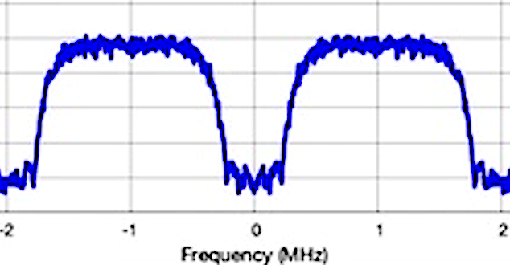
Fig. 1. Include whatever is required and describe what is in this figure blah, blah, blah ... baseband spectrum, showing FCC measured response from -2 to 2 MHz. termination. Image taken from [1]. Fix all captions!!

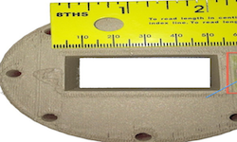
Fig. 2. Include whatever is required and describe what is in this figure blah, blah, blah ... bWR-90 waveguide antenna feed, showing flange and dimensions. Image taken from [1]. Fix all captions!!

References
At least 1 reference must be an IEEE paper
- T.P. Weldon, J.M.C. Covington III, K.L. Smith, and R.S. Adams ``Performance of Digital Discrete-Time Implementations of Non-Foster Circuit Elements,'' 2015 IEEE Int. Sym. on Circuits and Systems, Lisbon, Portugal, May 24-27, 2015.
- T.P. Weldon, J.M.C. Covington III, K.L. Smith, and R.S. Adams, ``Stability Conditions for a Digital Discrete-Time Non-Foster Circuit Element,'' 2015 IEEE Int. Symposium on Antennas and Propagation, Vancouver, BC, Canada, July 19-25, 2015.

