Project 99 Mini-Paper: 5G Radio Systems
Email one pdf file (not msword) to the TA, and turn in 1 hardcopy per group of students attached to the end of the project report.

Federico Faggin and Nolan Bushnell
Email: name1@uncc.edu and name2@uncc.edu

Abstract— Project reports may not exceed one page. This report summarizes Project 99: 5G radio systems. In this project, 5G radio systems were investigated, addressing the 4 items required for this report: 1) table of USA 5G frequency band, bandwidth, and bitrate, 2) formula for 5G antenna reflection, 3) snapshot of 5G power spectrum, and 4) photo of 5G antenna feed waveguide. The source of every item must be cited. You must have at least one relevant IEEE paper reference. Each item discussed must be in a separate section of the paper, the TA will NOT try to search for the required data, so place each requested item in a properly dedicated section. Attach this mini-paper to the end of your project reports, or as otherwise instructed.

5G System Parameter Table
The first reporting requirement was to find the USA 5G system frequency band, bandwidth, and bitrate. These specifications are taken from [1], and summarized in Table I.
- 5G System Parameters
Parameter | Value
5G frequency band | 10.11 GHz
5G bandwdith | 100 MHz
5G bitrate | 100-400 Mbit/s

5G Antenna Reflection Coefficient
The second reporting requirement was to find the formula for reflection on a 5G antenna feed. The reflection coefficient Γ for antenna impedance Z on a transmission line of impedance Z₀ is [2]

where V_{r} and V_{i} are the incident and reflected voltage amplitudes.

5G Transmitter Spectrum
The third reporting requirement was to find a plot of a typical 5G transmitter power spectrum. Fig. 1 shows the power spectrum from a FCC (federal communications commission( report on 5G experiments [3].
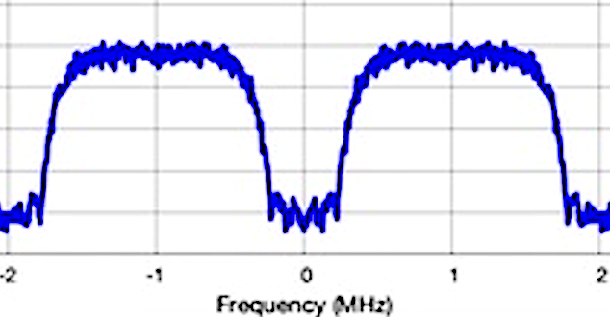
Fig. 1. 5G baseband spectrum, showing FCC measured response from -2 to 2 MHz. termination. Fix all captions!!

5G Antenna Waveguide Feed
The fourth reporting requirement was to find a photo of typical 5G transmitter waveguide feed for an antenna. Fig. 2 shows the 10.11 GHz 5G antenna feed for a WR-90 waveguide system [4].
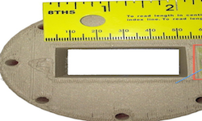
Fig. 2. 5G bWR-90 waveguide antenna feed, showing flange and dimensions. Fix all captions!!

References
At least 1 reference must be an IEEE paper
- FRDM-K64F Freedom Module User’s Guide. [Online]. Available: http://cache.freescale.com/files/32bit/doc/user_guide/FRDMK64FUG.pdfh
- T.P. Weldon, J.M.C. Covington III, K.L. Smith, and R.S. Adams ``Performance of Digital Discrete-Time Implementations of Non-Foster Circuit Elements,'' 2015 IEEE Int. Sym. on Circuits and Systems, Lisbon, Portugal, May 24-27, 2015.
- T.P. Weldon, J.M.C. Covington III, K.L. Smith, and R.S. Adams, ``Stability Conditions for a Digital Discrete-Time Non-Foster Circuit Element,'' 2015 IEEE Int. Symposium on Antennas and Propagation, Vancouver, BC, Canada, July 19-25, 2015.
- Wikipedia contributors, “Waveguide,” Wikipedia, The Free Encyclopedia, https://en.wikipedia.org/wiki/Waveguide, accessed 10 August 2018.

