Project Report: Put Your Report Title Here
Template: see website for instructions
Federico Faggin and Nolan Bushnell
Email: name1@uncc.edu and name2@uncc.edu

Abstract— See the website for all of the detailed requirements. Project reports may not exceed page limit. The project web-page information overrides any information contained in this template. This report summarizes the topic of your report ...,. The source of every item copied into the report must be cited. All figures must be clear and legible as would be submitted for IEEE publication. The examples in this template are not necessarily up to such clear and legible standards. You must include references in the bibliography for any formulas used.

Introduction
The first paragraph introduction should begin with an overall description of the “big picture” of the project topic, similar to the content in the abstract above, but stated somewhat diffferently and less details. blah blah blah blah blah blah blah blah blah blah blah blah blah blah blah blah blah blah blah blah blah blah blah blah blah blah blah
The second paragraph of the introduction should explain the organization of the rest oof the paper. In the next section we descrive the theory, ...blah blah. In Section III, we discuss various implemntations of the whatever. The following sectin describes simulations/measured/whatever ... blah blah blah blah blah blah blah blah blah blah blah blah blah blah blah blah blah blah blah blah blah blah blah blah blah blah

Theory (Change this title, if needed)
If you have theory, put it here. Say what the formula is for here ... is [1]
where you say what each variable is here blah, blah,blah ...V_{r} and V_{i} ??? are the incident and reflected voltage amplitudes.
If you have specifications or similar data, put it in a table of data ... describe what is in the table here. In Table I we list the blah, blah, blah ... . These specifications are taken from [1], and summarized in Table I.
- System Parameters(Change this title)
Parameter | Value
Name of parameter 1 here?? | 10.11 GHz??
Name of parameter 2 here?? | 100 MHz??
Name of parameter 2 here?? | 100-400 Mbit/s??

State of the Art (Change this title)
In this section, describe the state of the art of your topic. Include pictures of any devices or structures in several figures, as needed. Use one paragraph to describe each figure.
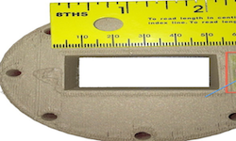
Fig. 1. Include whatever is required and describe what is in this figure blah, blah, blah ... bWR-90 waveguide antenna feed, showing flange and dimensions. Image taken from [1]. Fix all captions!!

Fig. 1 shows whatever... blah blah blah. In Fig. 1, we see the whatever plotted against whatever, where th top curce shaows whatever blah, blah, blah ... blah blah blah blah blah blah blah blah blah blah blah blah blah blah blah b describing the figure [2].
Fig. 2 shows whatever is required ... blah blah blah. In Fig. 2, we see the whatever plotted against whatever, blah blah blah blah blah blah blah blah blah blah blah blah blah blah blah bwhere th top curce shaows whatever blah blah blah blah blah blah blah blah blah blah blah blah blah blah blah bblah, blah, blah ... describing the figure [2].

Other Section (Change this title)
If you need another section for things such as measured data or simulations, put it here section, describe the state of the art of your topic. Include pictures of any devices or structures in several figures, as needed. blah blah blah blah blah blah blah blah blah blah blah blah blah blah blah blah bla
blah blah blah blah blah blah blah blah blah blah blah blah blah blah blah blah bla blah blah blah blah blah blah blah blah blah blah blah blah blah blah blah blah bla
blah blah blah blah blah blah blah blah blah blah blah blah blah blah blah blah bla

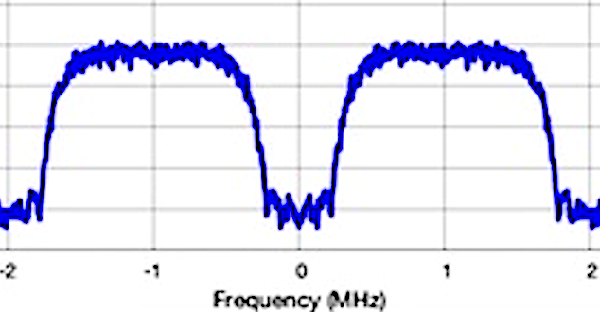
Fig. 1. Include whatever is required and describe what is in this figure blah, blah, blah ... baseband spectrum, showing FCC measured response from -2 to 2 MHz. termination. Image taken from [2]. Fix all captions!!

Fig. 3 shows whatever is required ... blah blah blah. In Fig. 2, we see the whatever plotted against whatever, blah blah blah blah blah blah blah blah blah blah blah blah blah blah blah bwhere th top curve shaows whatever blah blah blah blah blah blah blah blah blah blah blah blah blah blah blah bblah, blah, blah ... describing the figure [2].

Fig. 1. Include whatever is required and describe what is in this figure blah, blah, blah ... baseband spectrum, showing FCC measured response from -2 to 2 MHz. termination. Image taken from [2]. Fix all captions!!

Conclusion
Summarize any problems you may have encountered, or summarize what you learned from the items discussed in this paper. [2]. Dont forget to include your references, one must bea journal or conference paper. Do not use websites as references, all figures must be sourced from conference or journal papers.

References
At least 1 reference must be an IEEE paper
- T.P. Weldon, J.M.C. Covington III, K.L. Smith, and R.S. Adams ``Performance of Digital Discrete-Time Implementations of Non-Foster Circuit Elements,'' 2015 IEEE Int. Sym. on Circuits and Systems, Lisbon, Portugal, May 24-27, 2015.
- T.P. Weldon, J.M.C. Covington III, K.L. Smith, and R.S. Adams, ``Stability Conditions for a Digital Discrete-Time Non-Foster Circuit Element,'' 2015 IEEE Int. Symposium on Antennas and Propagation, Vancouver, BC, Canada, July 19-25, 2015.

