ECGR3122 Electromagnetic Waves
Email one pdf file (not msword), and turn in 1 hardcopy per group of students for grading.
Project 99: Time-Domain Reflection

Federico Faggin and Nolan Bushnell
Email: name1@uncc.edu and name2@uncc.edu

Abstract—This report summarizes Project 99: time-domain pulse reflections. In this project, time-domain pulse reflections were simulated in ADS and measured in the laboratory. The first four reflections (2 input pulses, 2 output pulses) of an xx ns pulse were measured on a yy foot long cable with zz ohm termination. The predicted reflection coefficient was Γ=xx, and measured was Γ=xx. Results included are: 1) schematics and theory, 2) ADS simulations, and 3) oscilloscope waveforms.

Introduction
Project reports must not exceed two pages. Pulses on transmission lines can produce multiple reflections when lines are not properly terminated [1]. You must have 1 relevant IEEE paper as part of 2 required references, and not websites as references. Two sentences right here should summarize the key points from those two references, and cite them [2]. This project compares theory, simulation, and measured results for pulse reflections on a transmission line. Theoretical and measured reflection coeficient Γ are compared for an xx ns pulse were measured on a yy foot long cable with zz ohm termination. The following sections present the theory, ADS simulation, and measured data.

Theory
The reflection coefficient Γ for load impedance Z ona transmission line of impedance Z₀ is [2] (provide a reference for any formula)

where V_{r} and V_{i} are the incident and reflected voltage amplitudes.
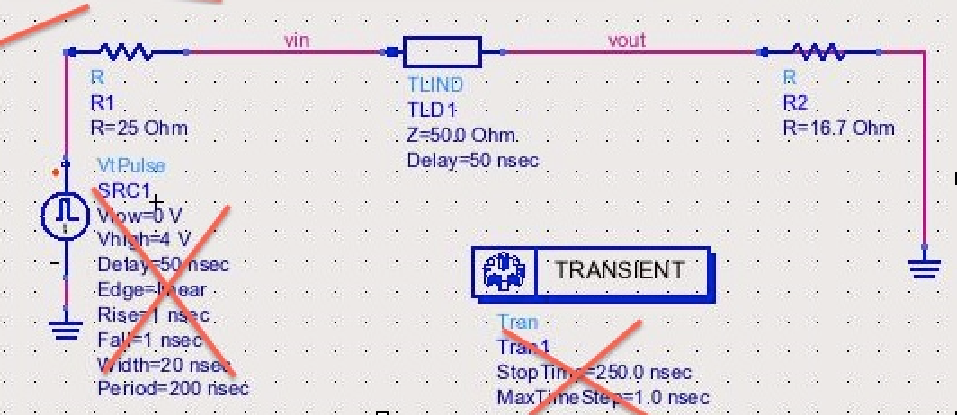
Fig. 1. System schematic, with an xx ns pulse were measured on a yy foot long cable with zz ohm termination. Fix all captions!!

The system under considerationis shown in Fig. 1, where a zz-ohm xx ns yy-volt pulse source drives a yy foot long cable with zz ohm termination. On the left side, the input reflection coefficient is Γ₁, and at the output on the right Γ₂. Finally, when the pulse returns round-trip to the input, it sees Γ₃. For an incident pulse of amplitude 1 volt, the computed reflection coefficients and total voltages are tabulated in Table I.
- Reflection Coefficients
Parameter | Value | Units
Γ₁ | 1.22
Cable length | 2.2 | m
Pulse Width | 5.3 | ns

Correspondingly, the total theoretical pulse voltage is [2]

where V_{tot} is the observed total voltage amplitude.

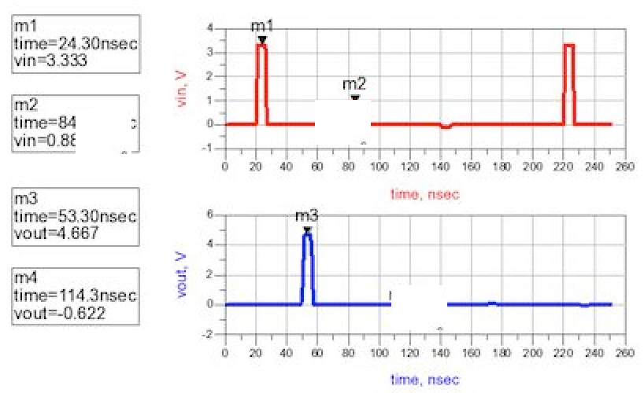
Fig. 2. Simulation results. The upper plot shows voltage at input of transmission line, the lower plot shows voltage at the output of the transmission line Fix all captions!!

Simulation
For your simulation data, include only the most important data and plots, and/or any specific items required by the project description. The system of Fig. 1 was simulated using Keysight ADS, where a yy ns input pulse of xx V was applied. The simulation results are given in Fig. 2, where the upper plot shows the pulse voltage at input of transmission line in red, and the lower plot shows the voltage at the output of transmission line in blue. The observed pulse voltages are summarized in Table II below.
- Simulated Pulse Voltages
Parameter | Theory | Measured
initial input pulse voltage | xx V | xa V
first output pulse | yy V | bb V
second input pulse | zz V | cc V
second output pulse | xx V | dd V

The simulation results of Table II agree with theoretical results to within 13%, and the discrepency is due to an error in our theory.
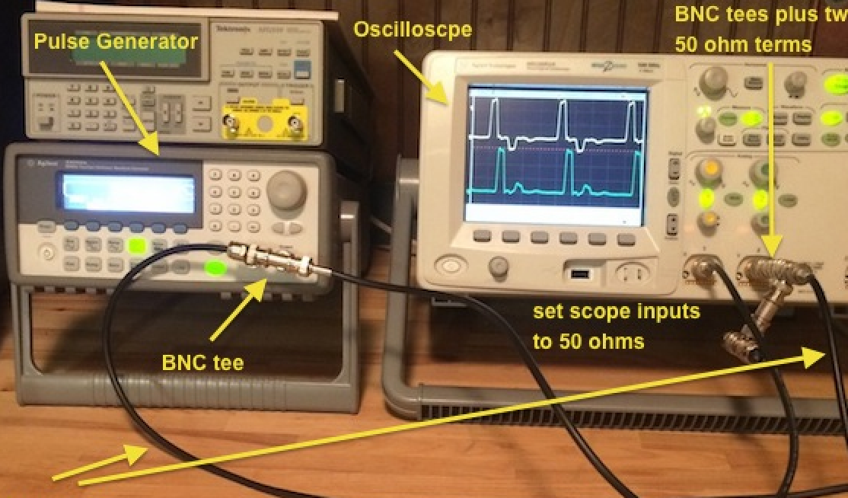
Fig. 3. Measurement setup. TAKE YOUR OWN PICTURE!!.

Measured Data
For your measured data, include only the most important data and oscilloscope plots, and/or any specific items required by the project description. The system of Fig. 1 was measured in the laboratory, where a yy ns input pulse of xx V was applied. The test setup is shown in Fig. 3.
The measured results are given in Fig. 4, where the upper plot shows the pulse voltage at input of transmission line in red, and the lower plot shows the voltage at the output of transmission line in blue. The observed pulse voltages are summarized in Table III below.
- Measured Pulse Voltages
Parameter | Theory | Measured
initial input pulse voltage | xx V | xa V
first output pulse | yy V | bb V
second input pulse | zz V | cc V
second output pulse | xx V | dd V

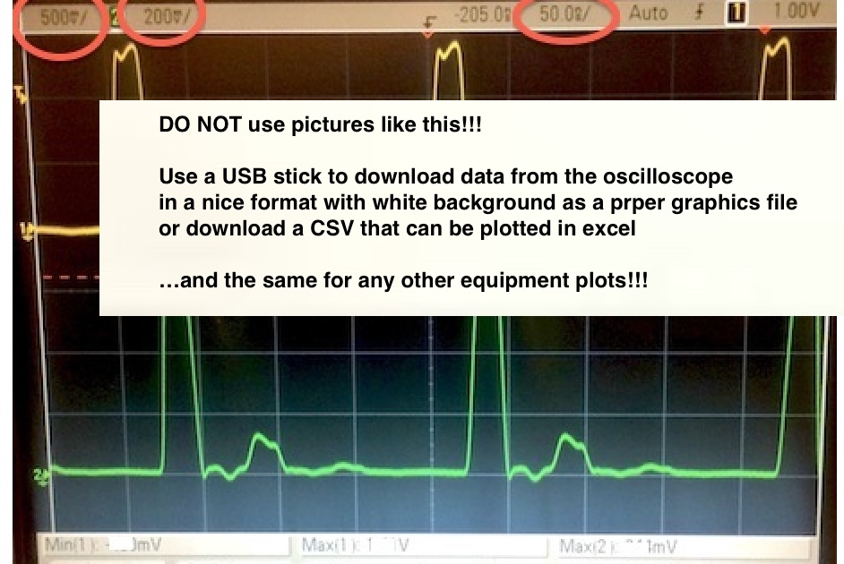
Fig. 4. Measured results. The upper plot shows voltage at input of transmission line, the lower plot shows voltage at the output of the transmission line Fix all captions!! Do not use photos like this, download proper graphics files with white background!!

The simulation results of Table III agree with theoretical results to within 13%, and the discrepency is due to another error in our theory.

Summary
Explain why something didn’t work if applicable.

DO NOT exceed 2 pages.

References

(Two references minumum are required)
At least 1 reference must be an IEEE paper
- FRDM-K64F Freedom Module User’s Guide. [Online]. Available: http://cache.freescale.com/files/32bit/doc/user_guide/FRDMK64FUG.pdfh
- T.P. Weldon, J.M.C. Covington III, K.L. Smith, and R.S. Adams ``Performance of Digital Discrete-Time Implementations of Non-Foster Circuit Elements,'' 2015 IEEE Int. Sym. on Circuits and Systems, Lisbon, Portugal, May 24-27, 2015.
- T.P. Weldon, J.M.C. Covington III, K.L. Smith, and R.S. Adams, ``Stability Conditions for a Digital Discrete-Time Non-Foster Circuit Element,'' 2015 IEEE Int. Symposium on Antennas and Propagation, Vancouver, BC, Canada, July 19-25, 2015.

