Digital Controls Final Project
copyright 2021, Thomas P. Weldon

Federico Faggin, Leon Chua, and Nolan Bushnell …not really
Email: name1@uncc.edu and name2@uncc.edu

Abstract—You MUST use this format and template. The project web-page information overrides any information contained in this template. This report summarizes Digital Controls Final Project: comparison of stat-variable and classical system design approaches. In this project, a continuous-time plant function was assigned to the group, with design goals for unity feedback and xx Hz sampling being steady-state error < xx% and settling time to within 1xx% of less than xx second. The first task was to design a classical digital PID/Lag-Lead/whatever controller D(z) to meet the goals. The second task was to design a digital state-variable observer and controller with pole placement to meet the goals. It was not possible to meet the design goals using a classical D(z) controller, and the best result was steady-state error xx% and settling time to within xx% of xx seconds. However, a successful digital state-variable observer and controller design achieved steady-state error 2.3% and settling time to within 10% of 0xx seconds Theory and simulation results are provided for the two designs.

Introduction
The project web-page information overrides any information contained in this template. Project reports may not exceed page limit, not including an appendix of your mattlab code. You must include tall formulas, tables, and figures as set forth on the web-page for this project. All figures must be clear and legible as would be submitted for IEEE publication. The examples in this template are not necessarily up to such clear and legible standards. You must include references in the bibliography for any formulas used.
The first paragraph introduction should begin with an overall description of the “big picture” of the project and goals, similar to the content in the abstract above, but stated somewhat diffferently and less details. blah blah blah blah blah blah blah blah blah blah blah blah blah blah blah blah blah blah blah blah blah blah blah blah blah blah blah blah blah blah blah blah blah blah blah blah blah blah blah blah blah blah blah blah blah blah blah blah blah blah blah blah blah blah blah blah blah blah blah blah blah blah blah blah blah blah blah blah blah blah
The second paragraph should describe your chosen approach to the classical controller [citation] (what type did you choose, and why you chose it), and approach to the state-variable controller [citation]. blah blah blah blah blah blah blah blah blah blah blah blah blah blah blah blah blah blah blah blah. blah blah blah blah blah blah blah blah blah blah blah blah blah blah blah blah blah blah blah blah blah blah blah blah blah blah blah blah blah blah blah blah blah blah blah This is the best paragraph to cite sources of your design theory. End the paragraph with a sentence long the lines of: “it was found that the xyz controller performed much better than the abc controller … most likely due to …whatever you conclude.”
The final paragraph should describe what the remaining sections discuss. “In the following section, the abc is described. Section III provides…. blah blah blah blah blah blah blah blah blah blah blah blah blah blah blah blah. Your introduction should not run more than an inch into the second column

Classical System Design
The block diagran for the digital PID/Lag-Lead/whatever controller and system is shown in Fig. 1, where sample time T₀=xx s, digital phase-lag controller D(z), with plant function Gc(s)= (1-e^{sTo})/[s(whatever)], feedback H(s)=xx/yy, and a ZOH included in Gc(s)=Gp(s)(1-e^{sTo})/s.
For this project, our assigned plant transfer function (including ZOH) was
(1)
with corresponding G(z)
                                            (2)                                 
where Ts=xx s for the sampler. And since H(s)=xx, the open-loop gain is G_{OL}(z)=???

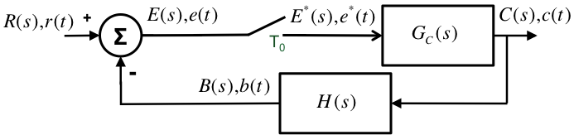
Fig. 1. System block diagram THIS FIGURE IS WRONG with T₀=0.1 s digital phase-lag controller D(z), with plant function Gc(s)= (1-e^{sTo})/[s(s+1)], feedback H(s)=1/4, and a ZOH. Fix this caption!!

s
The digital PID/Lag-Lead/whatever controller used in the classical system design approach is [1]

where K_{D} is whatever, z₀ is whatever, … w₀ is whatever, and so forth.
Make sure that: 1) all figures are legible, 2) captions describe critical items such phase margin, gain margin, frequency, bandwidth, pole locations, etc. The open-loop transfer function magnitude |G_{OL}(z)| and phase ∠G_{OL}(z) are shown in Fig. 2, using the digital controller D(z) of (3), plotted along with the uncompensted plant |G(z)| and ∠G(z) and controller plant |D(z)| and ∠D(z). As can be seen, the phase margin is zzzzz and the gain margin is zzzz.
zz
The open-loop transfer function magnitude |G_{OL}(z)| and phase ∠G_{OL}(z) are shown in Fig. 2, using the digital controller inof (2). As can be seen, the phase margin is zzzzz and the gain margin is zzzz. blah blah blah blah blah blah blah blah blah blah blah blah blah blah blah blah blah blah blah blah. blah blah blah blah blah blah blah blah blah blah blah blah blah blah blah blah blah blah blah blah blah blah blah blah blah blah blah blah blah blah blah blah blah blah
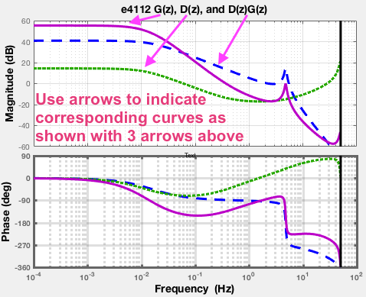
Fig. 2. Open-loop response G_{OL}(z) with compensator (solid), with T₀=0.1 s using digital whatever/PID/lag-lead controller D(z), along with the uncompensted plant (dashed) |G(z)| and ∠G(z) and compensator (dotted) |D(z)| and ∠D(z). BOTH magnitude and phase must be in same figure as shown here Fix this caption!!

The corresponding closed-loop transfer function magnitude |G_{CL}(z)| and phase ∠G_{CL}(z) are shown in Fig. 3 along with |G_{OL}(z)| and phase ∠G_{OL}(z), using the digital controller inof (2). As can be seen, the 3 dB closed-loop bandwidth is zzzzz and the dc gain is zzzzz. is zzzzz and the gain margin is zzzz.
blah blah blah blah blah blah blah blah blah blah blah blah blah blah blah blah blah blah blah blah. blah blah blah blah blah blah blah blah blah blah blah blah blah blah blah blah blah blah blah blah blah blah blah blah blah blah blah blah blah blah blah blah blah blahblah blah blah blah blah blah blah blah blah blah blah blah blah blah blah blah blah blah blah blah. blah blah blah blah blah blah blah blah blah blah blah blah blah blah blah blah blah blah blah blah blah blah blah blah blah blah blah blah blah blah blah blah blah blah
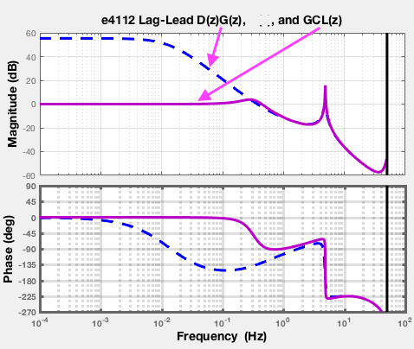
Fig. 3. Closed-loop frequency response G_{CL}(z), with T₀=xx s digital phase-lag controller D(z), along with open-loop response |G_{OL}(z)| and phase ∠G_{OL}(z) . Closed-loop gain is zzz, and bandwidth zz Hz. Fix this caption!!

A plot of the closed-loop step response is shown in Fg. 4. As can be seen, the settling time is zzzzz and the peak overshoot is zzzz. Ringing is also observed at a frequency of zzz, most likely due to a pole at zzz. Rise time ,,,, Steady-state error was observed blah blah blah blah blah blah blah blah blah blah blah blah blah blah blah. blah blah blah blah blah blah blah blah blah blah blah blah blah blah blah blah blah blah blah blah. blah blah blah blah blah blah blah blah blah blah blah blah blah blah blah blah blah blah blah blah blah blah blah blah blah blah blah blah blah blah blah blah blah blah blahblah
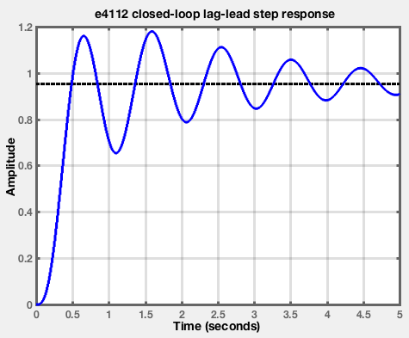
Fig. 4. Closed-loop step response for whatever/PID/lag-lead c(t.) Closed-loop gain is zzz, overshoot is zzz%, and rise time is zzz s. Fix this caption!!

blah blah blah blah blah blah blah blah blah blah blah blah blah blah blah blah blah blah
Table I lists the poles and zeroes of the closed loop system. All of the open-loop poles except one were stable, two closed-loop poles were unstable. blah blah blah blah blah blah. blah blah blah blah blah blah blah blah blah blah blah blah blah blah blah blah blah blah blah blah blah. blah blah blah blah blah blah blah blah blah blah blah blah blah
- poles of Open and Closed-Loop whatever/PID/lag-lead design
 | Complex Value | Magnitude
Open-loop Poles | 1+j1.11  2+j2.22  1+j3 | 2.2  3.1  5
Closed-loop Poles | 1+j2  2+j4 | 1.1111  3.3

Table II compares goals and observed performance for the whatever controler design. In Table II, summarize comparison between design goals and your final results. As shown in Table II below, 4 of the 5 goals were met. The final design goal of 12% was not met, because …whatever. blah blah blah blah blah blah. blah blah blah blah blah blah blah blah blah blah blah blah blah blah blah blah blah blah blah blah blah. blah blah blah blah blah blah blah blah blah blah blah blah blah Bla blah blah blahthe poles and zeroes of the open loop system..
- Design Goals and Results
Clock Signal Name | Design Goal | Final Design
Settilng time +/- 10% | 0.1 s | 7 s
Steady-state error | 5% | 11 %
Overshoot peak | 5 % | 22 %
Rise Time | 0.1 s | 3.3 s
Closed-loop 3 dB bandwidth | 2 Hz | 1.2 Hz

cblah blah blah blah blah blah blah blah blah blah blah blah blah blah blah blah blah blah blah blah. blah blah blah blah blah blah blah blah blah blah blah blah blah blah blah blah blah blah blah blah blah. blah blah blah blah blah blah blah blah blah blah blah blah blah bl blah blah blah blah blah blah. blah blah blah blah blah blah blah blah blah blah blah blah blah blah blah blah blah blah blah blah blah. blah blah blah blah blah blah blah blah blah blah blah blah blah blah blah blah blah blah blah. blah blah blah blah blah blah blah blah blah blah blah blah blah blah blah blah blah blah blah blah blah. blah blah blah blah blah blah blah blah blah blah blah blah blah

State-Variable Observer+Controller Design
The block diagram for the state-variable observer+controller digital compensator approach is shown in Fig. 5, where sample time T₀=0.1 s, and was
(4)
The state variables are derived from plant function G(s), resulting in :
. (5

blah blah blah blah blah blah blah blah blah blah blah blah blah blah blah blah. blah blah blah blah blah blah blah blah blah blah blah blah blah blah blah blah blah blah blah blah blah. blah blah blah blah blah blah blah blah blah blah blah blah blah

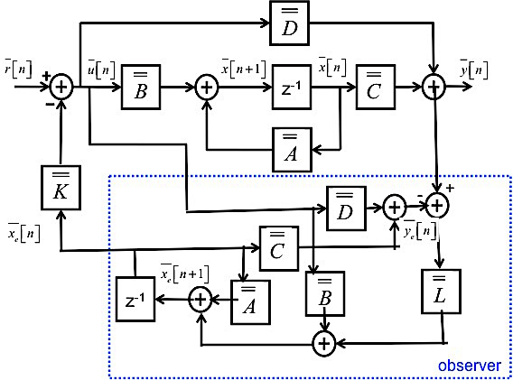
Fig. 5. State-variable observer and controller block diagram corresponding to system G_{C}(s) of Fig, 1. Make sure this is not wrong for you design. Fix this caption!!

A controller K was designed for a target pole placement polynomial of p(z) having poles at z={-1.0, -2.0, -3.0 not a good choice!}, where:
(6)
where Ts=0.01 s for the system. blah blah blah blah blah blah. blah blah blah blah blah blah blah blah blah blah blah blah blah blah blah blah blah blah blah blah blah. blah blah blah blah blah blah blah blah blah blah blah blah blah
An observer was designed with observer pole placement polynomial of p2(z) having poles at z={-4.0, -5.0, -6.0}, where:
(7)
where Ts=0.01 s for the system. blah blah blah blah blah blah. blah blah blah blah blah blah blah blah blah blah blah blah blah blah blah blah blah blah blah blah blah. blah blah blah blah blah blah blah blah blah blah blah blah blah
Fig. 6 shows the closed-loop frequency response for the state-variable digital observer+controller design, along with the losed-loop response of the classical design of the previous section. The state-variable design greatly reduced the peaking in the response while also improving bandwidth.. The bandwidth blah blah blah blah blah blah blah blah blah blah blah blah blah blah blah blah Bla blah blah blah blah blah blah blah blah blah blah blah blah blah blah blah blah blah blah blah blah blah blah blah blah blah blah blah blah blah blah blah blah blah blah blah.
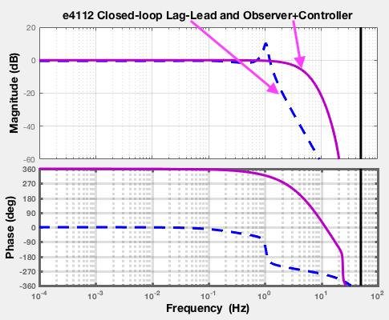
Fig. 6. Closed-loop frequency response for state-variable design (solid) and classical design (dashed), with T₀=0.1. BOTH magnitude and phase must be in same figure as shown here, Use arrows to indicate which curve is which as illustrated above Fix this caption!!

si Bla blah blah blah blah blah blah blah blah blah blah blah blah blah blah blah blah blah blah blah blah blah blah blah blah blah blah blah blah blah blah blah blah blah blah blah blah blah blah blah blah blah blah blah blah blah blah blah blah blah blah blah blah. Bla blah blah blah blah blah blah blah blah blah blah blah blah blah blah blah blah blah blah blah blah blah blah.
Fig. 7 shows the closed-loop step response for the state-variable digital observer+controller compensated design, along with the closed-loop response of the classical design of the previous section. The state-variable design greatly reduced the peaking in the response while also improving bandwidth.. Bla blah blah blah blah blah blah blah blah blah blah blah blah blah blah blah blah blah blah blah blah blah blah blah blah blah blah blah blah blah blah blah blah blah blah blah blah blah blah blah blah blah blah blah blah blah blah blah blah blah blah blah blah. Bla blah blah blah blah blah blah blah blah blah blah blah blah blah blah blah blah blah blah blah blah blah blah blah blah blah blah blah blah blah blah blah blah. Bla blah blah blah blah blah blah blah blah blah blah blah blah blah blah blah blah blah blah blah blah blah blah blah blah blah blah blah blah blah blah blah blah blah blah blah blah blah blah blah blah blah blah blah blah blah blah blah blah blah blah blah blah. Bla blah blah blah blah blah blah blah blah blah blah blah blah blah blah blah blah blah blah blah blah blah blah blah blah blah blah blah blah blah blah blah blah blah blah blah blah blah blah blah blah blah blah blah blah blah blah blah blah blah blah blah blah.
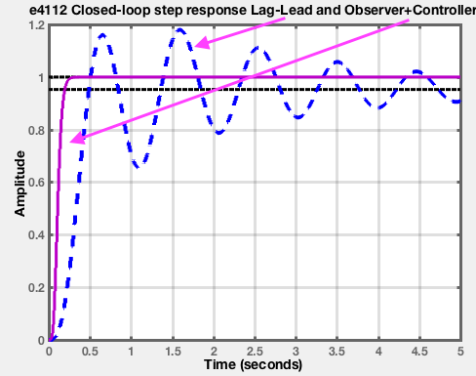
Fig. 7. Closed-loop step response for state-variable design (solid) and classical design (dashed), with T₀=0.1. BOTH magnitude and phase must be in same figure as shown here, Use arrows to indicate which curve is which as illustrated above Fix this caption!!

Table III lists the poles and zeroes of the closed-loop compensated observer+controller state-variabe system. All of the open-loop poles except one were stable, two closed-loop poles were unstable. blah blah blah blah blah blah. blah blah blah blah blah blah blah
- Poles of Closed-Loop State-Variable Design
 | Complex Value | Magnitude
Closed-loop Poles | 1+j1.11  2+j2.22  1+j3  1+j2  2+j4 | 2.2  3.1  51.1111  3.3  44

blah blah blahblah blah blah blah blah blah blah blah blah blah blah blah blah blah blah blah blah blah blah blah blah blah. Bla blah blah blah blah blah blah blah blah blah blah blah blah blah blah blah blah blah blah blah blah blah blah blah blah blah blah blah blah blah blah blah blah. Bla blah blah blah blah blah blah blah

Comparisons of Both Methods to Design Goals
In Table IV, summarize comparison between design goals and your final results for both the classical design and the . As shown in Table III below, all goals were met using the state variable controller, while 4 goals were not met using the classical whatever/PID controller. The final design goal of 12% was not met, because …whatever. Bla blah blah blah blah blah blah blah blah blah blah blah blah blah Bla blah blah blah blah blahblah blah
blah blah blah blah blah blah blah blah blah blah blah blah blah blah blah blah blah blah blah blah. Bla blah blah blah blah blah blah blah blah blah blah blah blah blah blah blah blah blah blah blah blah blah blah blah blah blah blah blah blah blah blah blah blah. Bla blah blah blah blah blah blah blah

Table II compares goals andblah blah blah blah blah blah blah blah blah blah blah blah blah blah blah blah blah blah blah blah blah blah blah blah blah blah blah blah blah blah blah blah blah blah blah blah blah blah blah blah blah blah blah blah blah blah blah zeroes of the open loop system..
- Design Goals and Results for Both Methods
Clock Signal Name | Design Goal | Classical  Design | State Variable
Settilng time +/- 10% | 0.1 s | 7 s | 1 s
Steady-state error | 5% | 11 % | 2 %
Overshoot peak | 5 % | 22 % | 3 %
Rise Time | 0.1 s | 3.3 s | 4 s
Closed-loop 3 dB bandwidth | 2 Hz | 1.2 Hz | 5 Hz

In addition, Bla blah blah blah blah blah blah blah blah blah blah blah blah blah blah blah blah blah blah blah blah blah blah blah blah blah blah blah blah blah blah blah blah blah blah blah blah blah blah blah blah blah blah blah blah blah blah blah blah blah blah blah blah

Summary
Two digital controllers were designed, ….. Bla blah blah blah blah blah blah blah blah blah blah blah blah blah blah blah blah blah blah blah blah blah blah blah blah blah blah blah blah blah blah blah blah blah blah blah blah blah blah blah blah blah blah blah blah blah blah blah blah blah blah blah blah.
Reasons why you failed Bla blah blah blah blah blah blah blah blah blah blah blah blah blah blah blah blah blah blah blah blah blah blah blah blah blah blah blah blah blah blah blah blah blah blah blah blah blah blah blah blah blah blah blah blah blah blah blah blah blah blah blah blah.
Reasons why you succeeded Bla blah blah blah blah blah blah blah blah blah blah blah blah blah blah blah blah blah blah blah blah blah blah blah blah blah blah blah blah blah blah blah blah blah blah blah blah blah blah blah blah blah blah blah blah blah blah blah blah blah blah blah blah.

References (Two references minumum are required)

- Phillips and Nagle and Ch …..fix this reference!
- Fix this reference and replace with your referencesT.P. Weldon, J.M.C. Covington III, K.L. Smith, and R.S. Adams ``Performance of Digital Discrete-Time Implementations of Non-Foster Circuit Elements,'' 2015 IEEE Int. Sym. on Circuits and Systems, Lisbon, Portugal, May 24-27, 2015.
- T.P. Weldon, J.M.C. Covington III, K.L. Smith, and R.S. Adams, ``Stability Conditions for a Digital Discrete-Time Non-Foster Circuit Element,'' 2015 IEEE Int. Symposium on Antennas and Propagation, Vancouver, BC, Canada, July 19-25, 2015.

THE APPENDIX SHOULD APPEAR on THE NEXT PAGE

NOT HERE

YOU MUST INCLUDE A COMPLETE MATTLAB SCRIPT THAT GENRATES ALL YOUR FIGURES AND DESIGNS/DATA

Appendix 1

Mattlab Script

YOU MUST INCLUDE A COMPLETE MATTLAB SCRIPT THAT GENRATES ALL YOUR FIGURES AND DESIGNS/DATA

%% copyright 2017 by Thomas Weldon

Ts = 0.1; %sample rate
Gps = tf([1],[1 1 0]); %plant function
Gpz = c2d(Gps, Ts, 'zoh');
Gpz
Hs = tf(1,1); %feedback continuous-time filter
Hz = c2d(Hs, Ts, 'zoh');
Dz = tf([1 1],[1 0],Ts); %digital filter
Ds = d2c(Dz,'Tustin');
Gfwdz = series(Dz,Gpz);
Gfwds = series(Ds,Gps);
Golz = series(Gfwdz,Hz);
Gols = series(Gfwds,Hs);
Gclz = feedback(Gfwdz, Hz); %closed loop pulse trans func
Gcls = feedback(Gfwds, Hs);

figure(1);
set(gca,'linewidth',3.0);
bplt=bodeplot(Golz)
setoptions(bplt,'FreqUnits','Hz','grid','on','YLim',[0 70],'XLim',[0.0001 10]);
title('Open loop response D(z)Gc(z)H(z)')
%legend('C(z)/R(z)','Location','northwest')
aa=gca
aa.XGrid='on';aa.YGrid='on';aa.LineWidth=3;aa.FontWeight='bold';
aa.XLabel.FontSize=20;aa.YLim=[-200 0];
set(findall(gcf,'Type','line'),'LineWidth',3);
set(findall(gca,'Type','line'),'LineWidth',3);
set(findall(gcf,'Type','text'),'FontSize',14);
set(findall(gcf,'Type','text'),'FontWeight','bold');

figure(2);
set(gca,'linewidth',3.0);
opt = bodeoptions;
bplt=bodeplot(Gclz)
%{maglimits;phaselimits}
setoptions(bplt,'FreqUnits','Hz','grid','on','YLim',[0 40],'XLim',[0.0001 10]);
title('Closed loop response C(z)/R(z)')
%legend('C(z)/R(z)','Location','northwest')
aa=gca
aa.XGrid='on';aa.YGrid='on';aa.LineWidth=3;aa.FontWeight='bold';
aa.XLabel.FontSize=20;aa.YLim=[-200,0];
set(findall(gcf,'Type','line'),'LineWidth',3);
set(findall(gca,'Type','line'),'LineWidth',3);
set(findall(gcf,'Type','text'),'FontSize',14);
set(findall(gcf,'Type','text'),'FontWeight','bold');

figure(3);
set(gca,'linewidth',3.0);
%zplane(Z,P) plots the zeros Z and poles P (in column vectors) with the
pzmap(Gclz)
title('Closed loop poles and zeroes')
axis([-1.5 1.5 -1.5 1.5]);
%zeta = [ 0.25 0.5 0.75];
Wn = [0.25 0.5 0.75]*3;
aa=gca
aa.XGrid='on';aa.YGrid='on';aa.LineWidth=3;aa.FontWeight='bold';
aa.XLabel.FontSize=20;aa.FontSize=12;
set(findall(gcf,'Type','line'),'LineWidth',3);
set(findall(gcf,'Type','text'),'FontSize',14);
set(findall(gcf,'Type','text'),'FontWeight','bold');

%% E4112 Project 7 Matlab
%% copyright 2017 by Thomas Weldon

close all
clear all

Ts = 0.01; %sample period
fmax=100 ; %max freq for plotting
fmin =fmax/100000;
Gp.s = tf([10000],[1 70 1000 0]); %plant function 10,000/s(s+20)(s+50)
Gp.z = c2d(Gp.s, Ts, 'zoh');
Gp.z
H.s = tf([1],[10]); %feedback continuous-time filter
H.z = c2d(H.s, Ts, 'zoh');
H.z

%***********************************************
% enter your PID design coefficients here
kp=1; ki=2; kd=3;
pidCtrl=pid(kp,ki,kd,0,Ts,'IFormula','Trapezoidal','DFormula','BackwardEuler');
pid.z=tf(pidCtrl);
D.z=pid.z
D.s = d2c(D.z,'Tustin');
Gfwd.z = series(D.z,Gp.z);
Gfwd.s = series(D.s,Gp.s);
Gol.z = series(Gfwd.z,H.z);%compensated open loop response
GolUncomp.z=series(Gp.z,H.z);%uncompensated open loop response
Gol.s = series(Gfwd.s,H.s);
Gcl.z = feedback(Gfwd.z, H.z); %closed loop pulse trans func
Gcl.s = feedback(Gfwd.s, H.s);

figure(1);
set(gca,'linewidth',3.0);
aa=gca
aa.XGrid='on';aa.YGrid='on';aa.LineWidth=3;aa.FontWeight='bold';
aa.XLabel.FontSize=20;aa.YLim=[-225 0];
set(findall(gcf,'Type','line'),'LineWidth',3);
set(findall(gca,'Type','line'),'LineWidth',3);
set(findall(gcf,'Type','text'),'FontSize',14);
set(findall(gcf,'Type','text'),'FontWeight','bold');
bplt=bodeplot(Gol.z)
setoptions(bplt,'FreqUnits','Hz','grid','on','YLim',[-20 60],'XLim',[fmin fmax]);
title('e4112 compensated open loop response')
%legend('C(z)/R(z)','Location','northwest')
aa=gca
aa.XGrid='on';aa.YGrid='on';aa.LineWidth=3;aa.FontWeight='bold';
aa.XLabel.FontSize=20;aa.YLim=[-225 0];
set(findall(gcf,'Type','line'),'LineWidth',3);
set(findall(gca,'Type','line'),'LineWidth',3);
set(findall(gcf,'Type','text'),'FontSize',14);
set(findall(gcf,'Type','text'),'FontWeight','bold');

figure(2);
set(gca,'linewidth',3.0);
bplt=bodeplot(Gcl.z)
setoptions(bplt,'FreqUnits','Hz','grid','on','YLim',[-20 30],'XLim',[fmin fmax]);
title('e4112 closed loop response C(z)/R(z)')
%legend('C(z)/R(z)','Location','northwest')
aa=gca
aa.XGrid='on';aa.YGrid='on';aa.LineWidth=3;aa.FontWeight='bold';
aa.XLabel.FontSize=20;aa.YLim=[-90 90];
set(findall(gcf,'Type','line'),'LineWidth',3);
set(findall(gca,'Type','line'),'LineWidth',3);
set(findall(gcf,'Type','text'),'FontSize',14);
set(findall(gcf,'Type','text'),'FontWeight','bold');

figure(3);
set(gca,'linewidth',3.0);
%zplane(Z,P) plots the zeroes Z and poles P (in column vectors) with the
pzmap(Gcl.z);
title('Closed loop response C(z)/R(z) poles and zeroes')
axis([-1.5 1.5 -1.5 1.5]);
%zeta = [ 0.25 0.5 0.75];
Wn = [0.25 0.5 0.75]*3;
aa=gca
aa.XGrid='on';aa.YGrid='on';aa.LineWidth=3;aa.FontWeight='bold';
aa.XLabel.FontSize=20;aa.FontSize=12;
set(findall(gcf,'Type','line'),'LineWidth',3);
set(findall(gcf,'Type','text'),'FontSize',14);
set(findall(gcf,'Type','text'),'FontWeight','bold');

